Write a Program to Output a string to Console.

#include <stdio.h>

#include <conio.h>

void main()

{

clrscr();

printf("Hello World.");

getch();

}

Output:

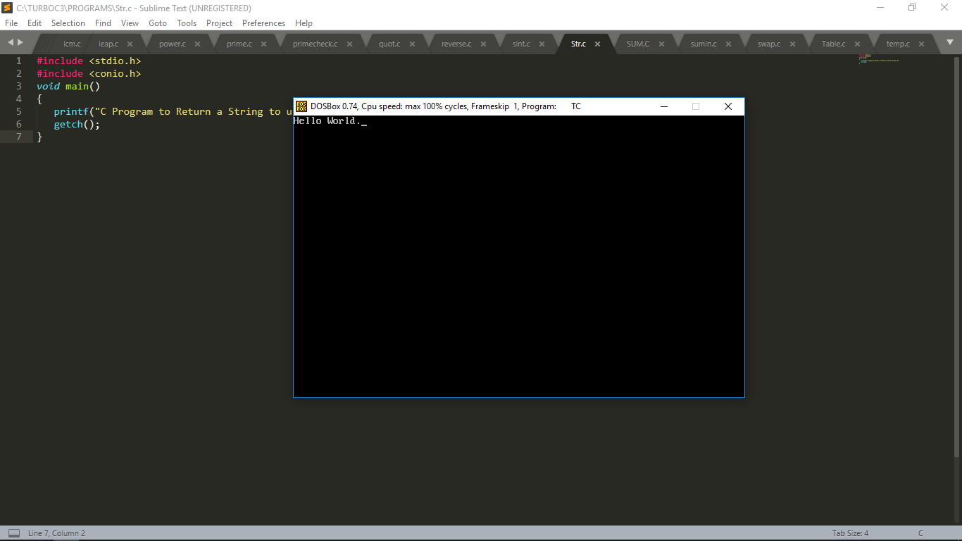

Program to add two Integers.

#include <stdio.h>

#include <conio.h>

void main()

{

int a, b, sum;

clrscr();

printf("Enter two Integers for addition: \n");

scanf("%d %d", &a , &b);

sum = a+b;

printf("\n%d + %d = %d",a ,b ,sum);

getch();

}

Output:

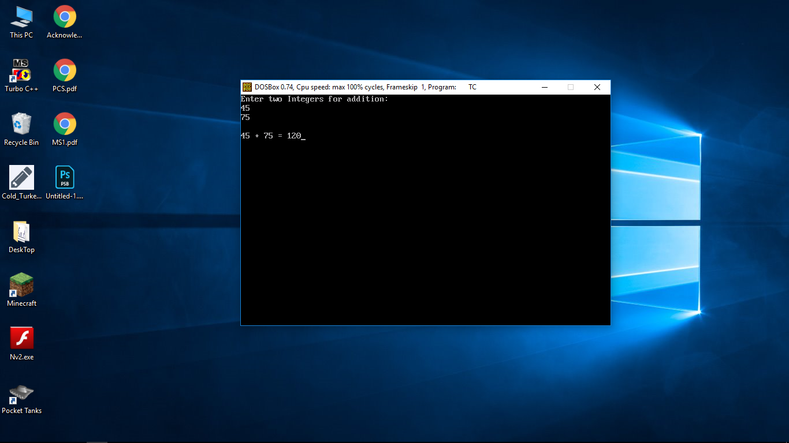

Program to Check whether a Year is Leap Year or Not.

#include <stdio.h>

#include <conio.h>

void main()

{

int year;

clrscr();

printf("Enter the year: ");

scanf("%d" ,&year);

if ( year%4==0 )

{

printf("\n%d is a Leap year." ,year);

}

else

{

printf("\n%d is not a Leap year." ,year);

}

getch();

}

Output:

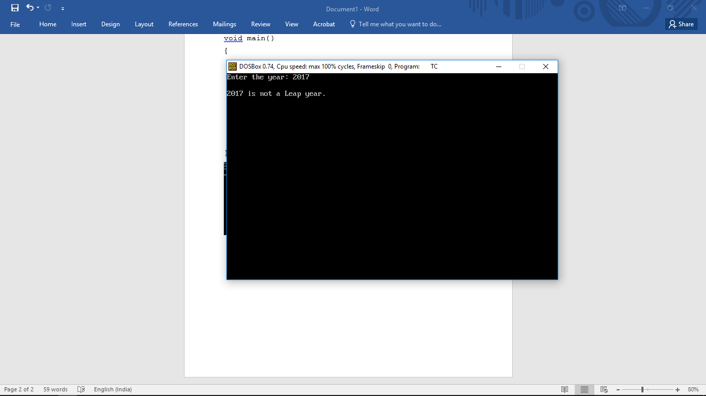

Program to find average of two numbers.

#include <stdio.h>

#include <conio.h>

void main()

{

int a, b;

float avg;

clrscr();

printf("Enter first number :");

scanf("%d",&a);

printf("Enter second number :");

scanf("%d",&b);

avg= (float)(a+b)/2;

printf("\nAverage of %d and %d is = %f",a,b,avg);

getch();

}

Output:

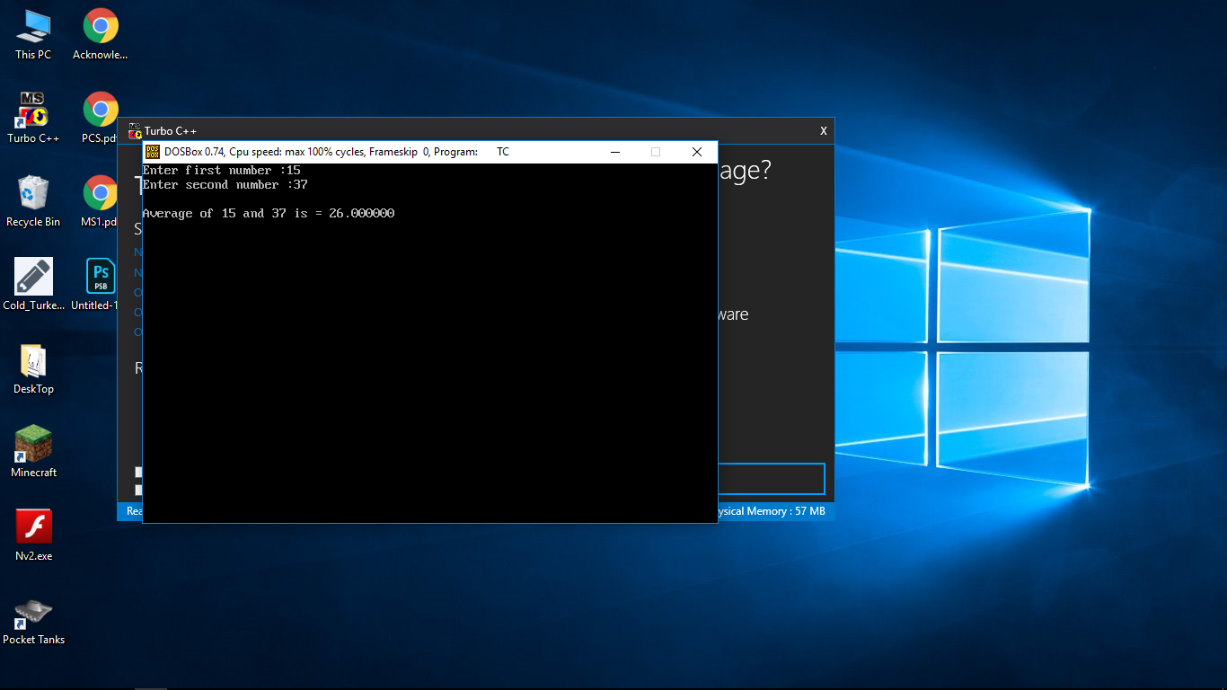

Program to find sum of first N Numbers.

#include <stdio.h>

#include <conio.h>

void main()

{

int i, num, sum = 0;

clrscr();

printf("Enter a number to find sum upto: ");

scanf ("%d", &num);

for (i = 1; i <= num; i++)

{

sum += i;

}

printf ("Sum of first %d natural numbers = %d\n", num, sum);

getch();

}

Output:

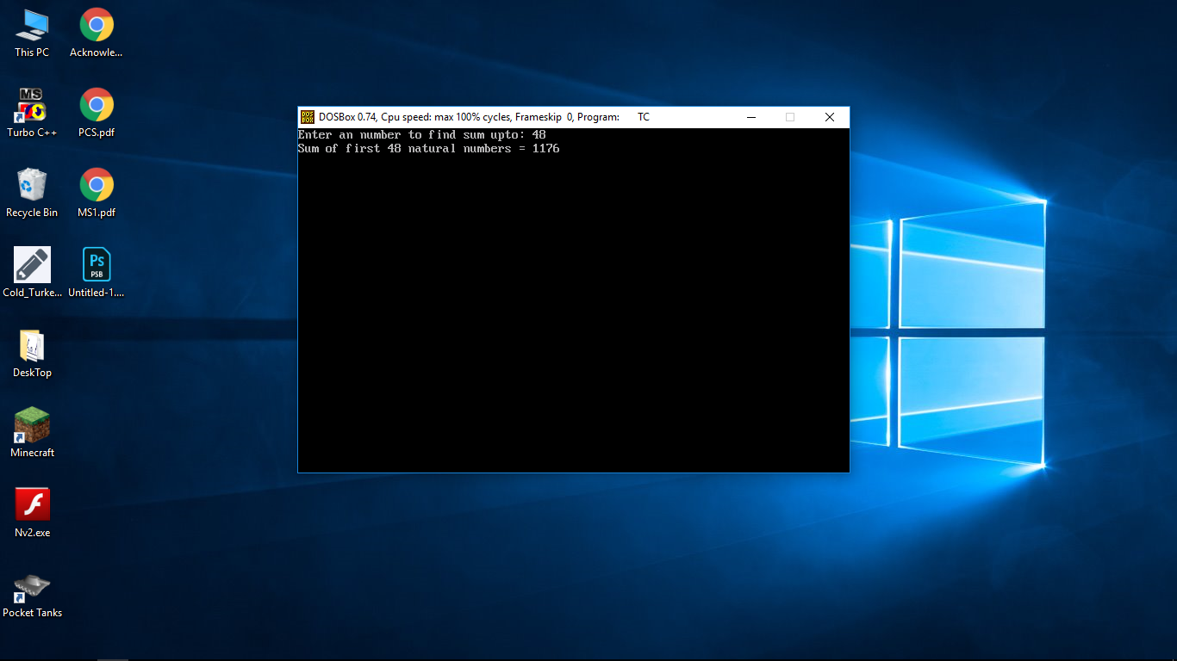

Program to swap Values stored in two variables.

#include <stdio.h>

#include <conio.h>

void main()

{

int val1, val2, temp=0;

clrscr();

printf("Enter First Integer: ");

scanf("%d" ,&val1);

printf("\nEnter Second Integer: ");

scanf("%d" ,&val2);

printf("\nYour Entered Values are %d & %d" ,val1 ,val2);

{

temp=val1;

val1=val2;

val2=temp;

}

printf("\nValues after swapping are %d & %d" ,val1 ,val2);

getch();

}

Output:

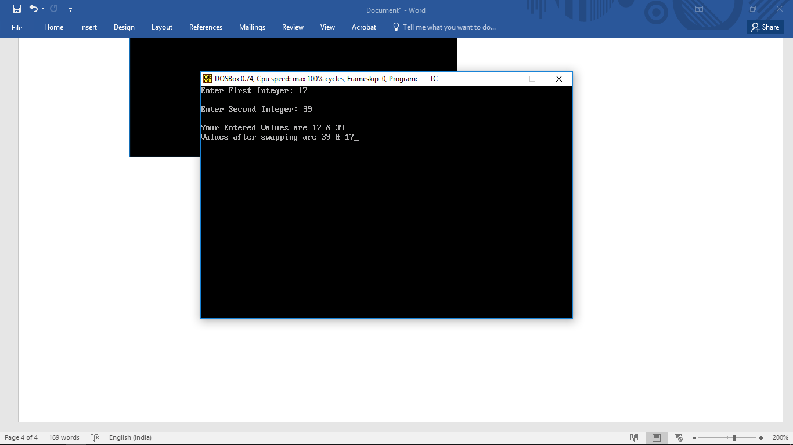

Program to find ASCII value of given character.

#include <stdio.h>

#include <conio.h>

void main()

{

char c;

clrscr();

printf("Enter a character to find its ASCII value: ");

scanf("%c",&c);

printf("\nASCII value of %c is %d" ,c ,c);

getch();

}

Output:

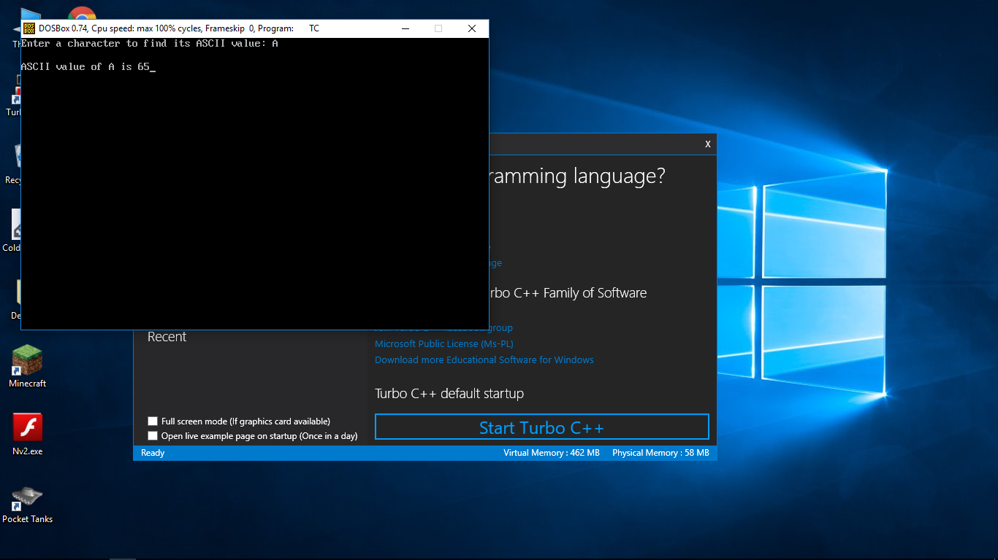

Program to find Area and Perimeter of a Circle.

#include <stdio.h>

#include <conio.h>

#define PI 3.14

void main()

{

float rad,area, perm;

clrscr();

printf("Enter radius of circle: ");

scanf("%f",&rad);

area=PI*rad*rad;

perm=2*PI*rad;

printf("Area of circle: %f \nPerimeter of circle: %f" ,area ,perm);

getch();

}

Output:

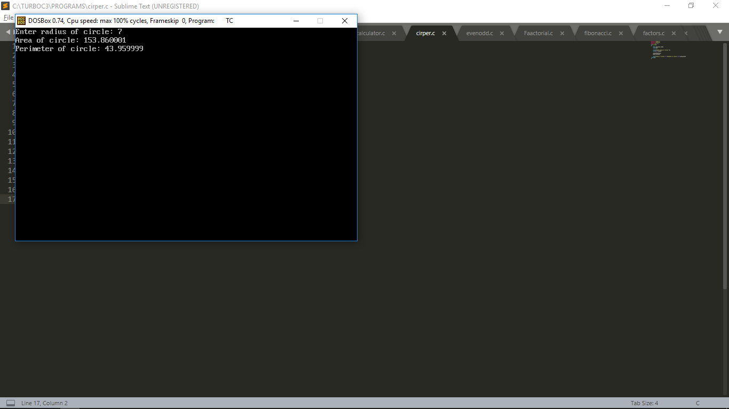

Program to find whether an Integer is even or odd.

#include <stdio.h>

#include <conio.h>

void main()

{

int v=0, rem;

clrscr();

printf("Enter an Integer: ");

scanf("%d", &v);

rem=v%2;

if (rem == 0)

printf("\n%d is an even Integer\n",v);

else

printf("\n%d is an odd Integer\n",v);

getch();

}

Output:

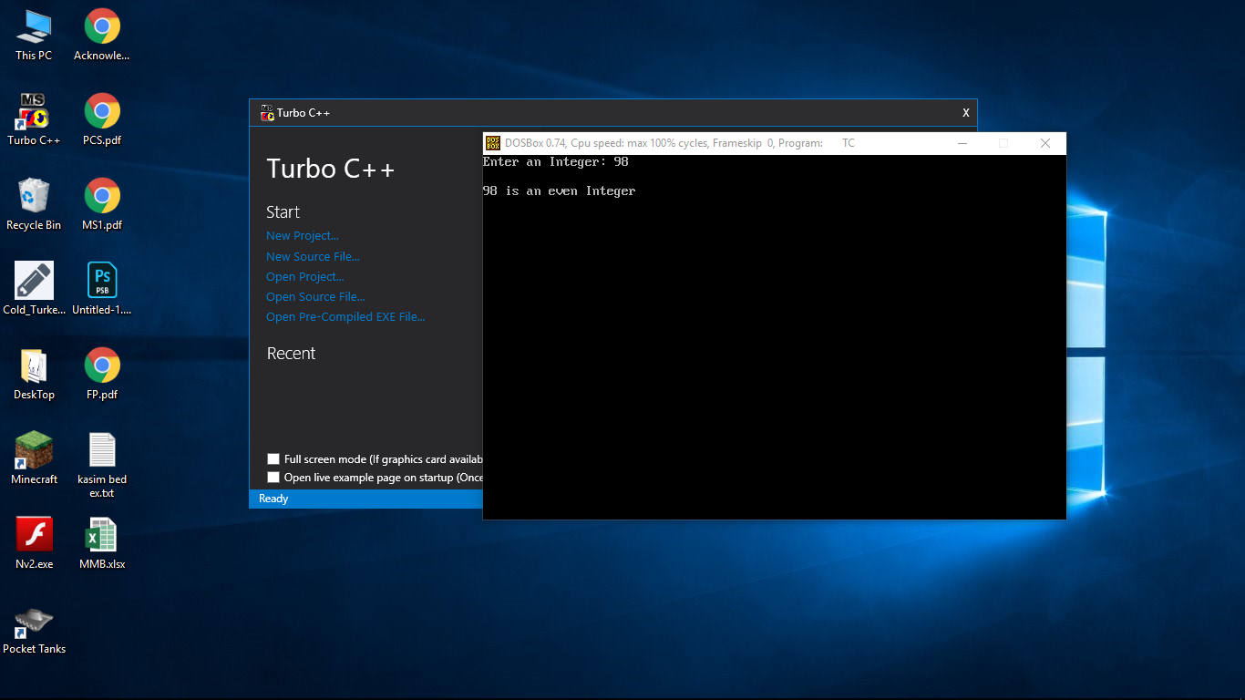

Program to find all Possible Factors of a given positive integer.

#include <stdio.h>

#include <conio.h>

void main()

{

int number, i;

clrscr();

printf("Enter a positive integer: ");

scanf("%d",&number);

printf("Factors of %d are: ", number);

for(i=1; i <= number; ++i)

{

if (number%i == 0)

{

printf(" %d ",i);

}

}

getch();

}

Output:

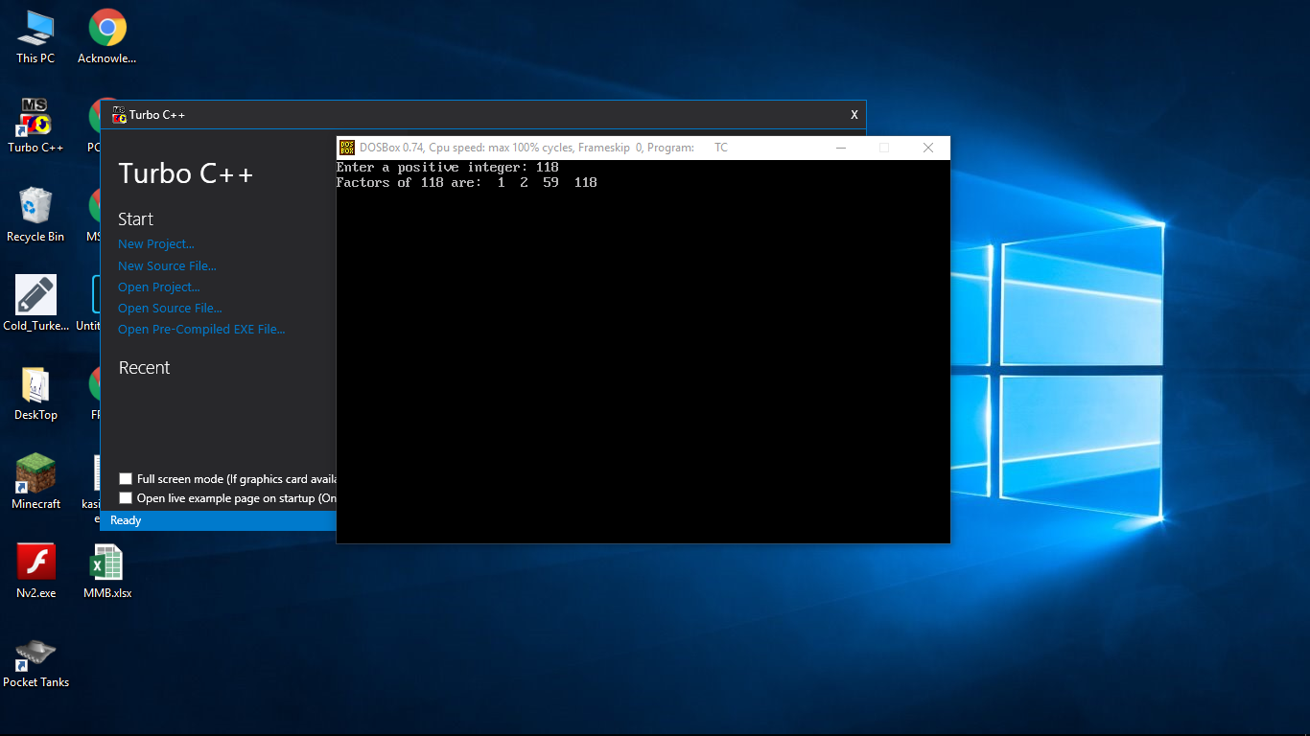

Program to get Fibonacci series up to Nth term.

#include <stdio.h>

#include <conio.h>

void main()

{

int i, n, t1 = 0, t2 = 1, nextTerm;

clrscr();

printf("Enter the number of terms: ");

scanf("%d", &n);

printf("Fibonacci Series: ");

for (i = 1; i <= n; ++i)

{

printf("\n%d", t1);

nextTerm = t1 + t2;

t1 = t2;

t2 = nextTerm;

}

getch();

}

Output:

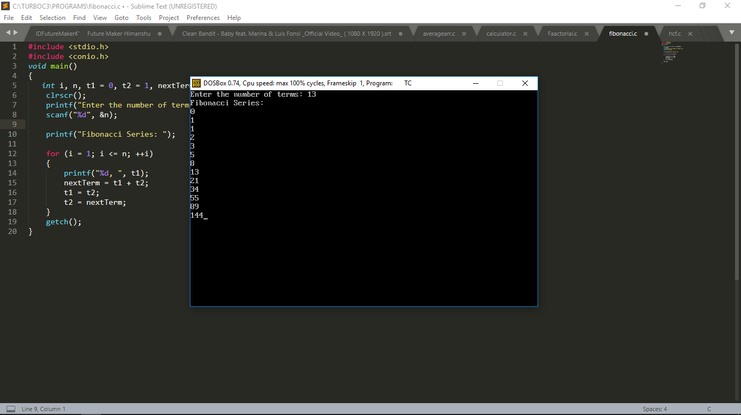

Program to find Factorial of a given positive integer.

#include <stdio.h>

#include <conio.h>

void main()

{

int i, n;

unsigned long long fact=1;

clrscr();

printf("Enter an Positive Integer to find Factorial of: ");

scanf("%d" ,&n);

if ( n<0 )

printf("\nError! You Entered a Negative Value");

else

{

for (i = 1; i <= n; ++i)

{

fact *= i;

}

printf("\nFactorial of %d is %llu" ,n ,fact);

}

getch();

}

Output:

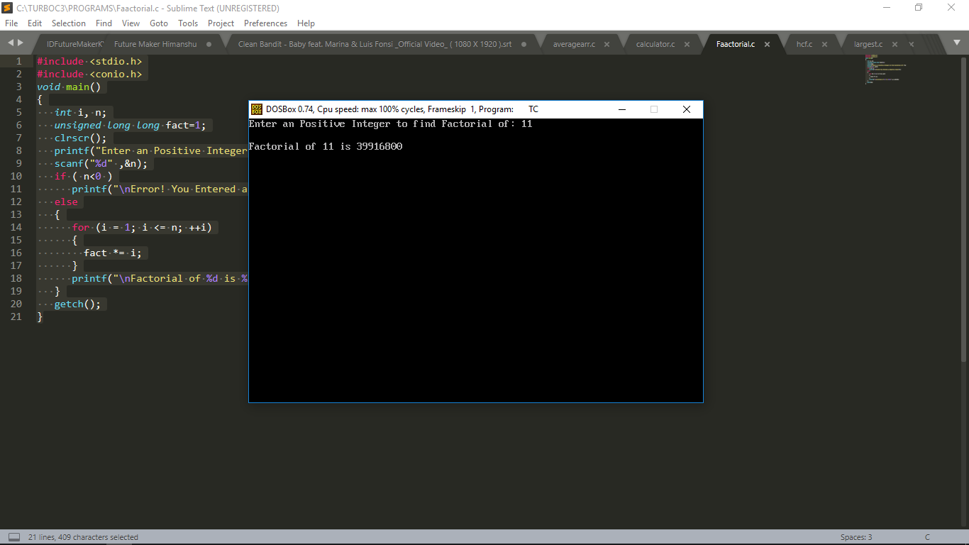

Program to find the largest integer in an array.

#include <stdio.h>

#include <conio.h>

void main()

{

int i, n;

int arr[999], temp;

clrscr();

printf("Enter total number of elements(1 to 100): ");

scanf("%d", &n);

printf("\n");

for(i = 0; i < n; ++i)

{

printf("Enter Number %d: ", i+1);

scanf("%d", &arr[i]);

}

for(i = 1; i < n; ++i)

{

if(arr[0] < arr[i])

{

temp = arr[0];

arr[0] = arr[i];

arr[i] = temp;

}

}

printf("Largest element = %d", arr[0]);

getch();

}

Output:

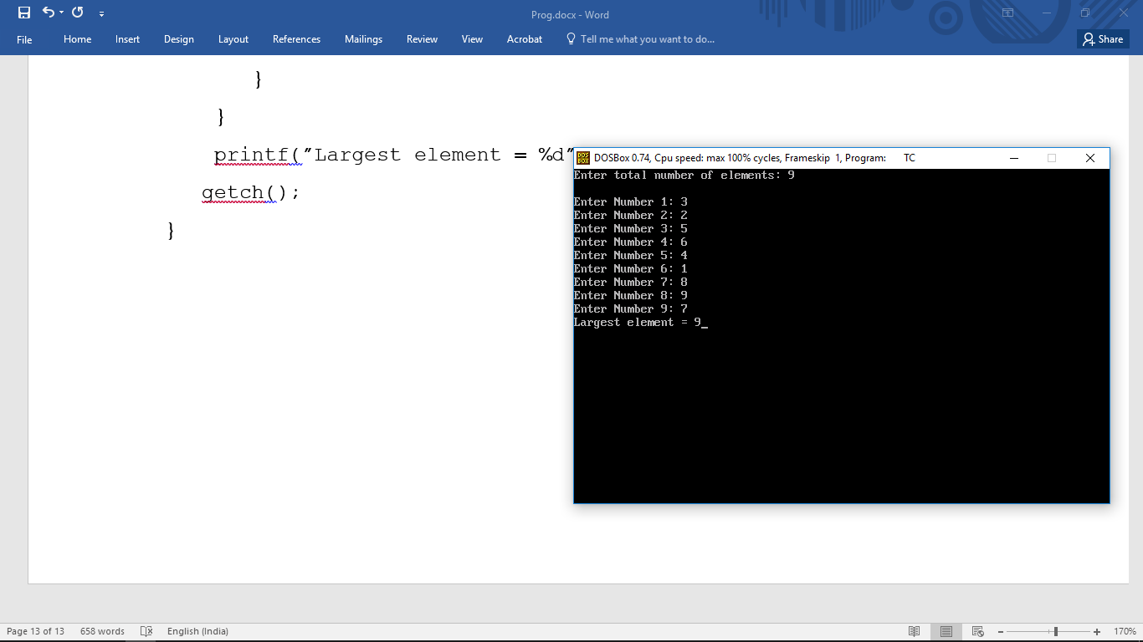

Program to find average of given Integers in an Array.

#include <stdio.h>

#include <conio.h>

void main()

{

int marks[10], i, n;

float sum = 0, average;

clrscr();

printf("Enter No. of Integers to find Average from: ");

scanf("%d", &n);

for(i=0; i<n; ++i)

{

printf("Enter number%d: ",i+1);

scanf("%d", &marks[i]);

sum += marks[i];

}

average = sum/n;

printf("Average = %f", average);

getch();

}

Output:

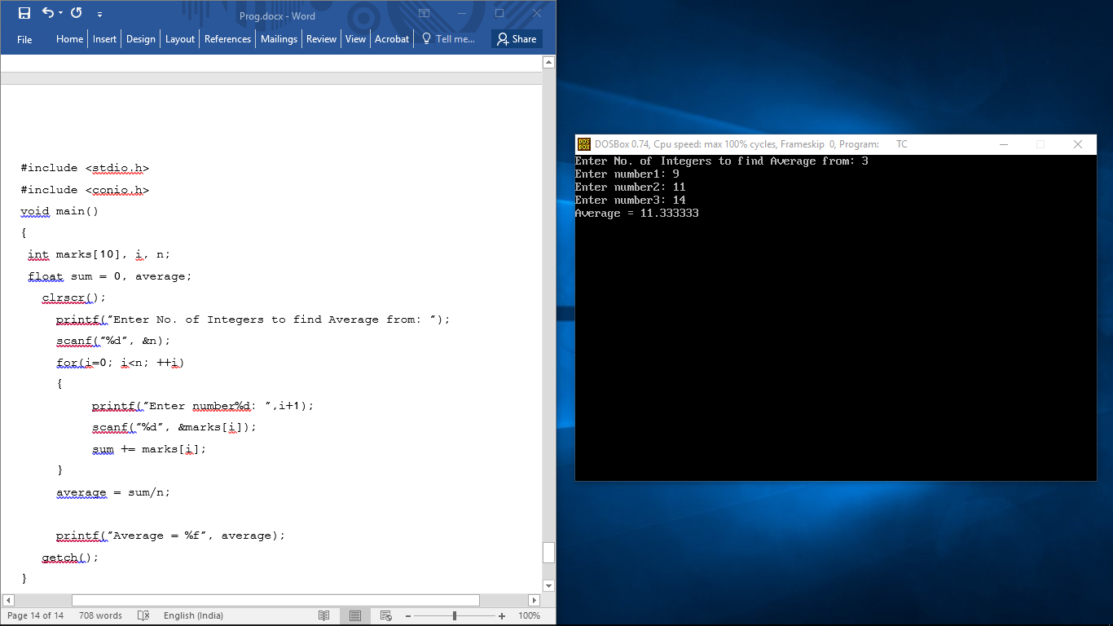

Program to Convert Celsius to Fahrenheit & Vice Versa.

#include <stdio.h>

#include <conio.h>

void main()

{

float fh,cl;

int choice;

clrscr();

printf("\n1: Convert temperature from Fahrenheit to Celsius.");

printf("\n2: Convert temperature from Celsius to Fahrenheit.");

printf("\nEnter your choice (1, 2): ");

scanf("%d",&choice);

if(choice ==1){

printf("\nEnter temperature in Fahrenheit: ");

scanf("%f",&fh);

cl= (fh - 32) / 1.8;

printf("Temperature in Celsius: %.2f",cl);

}

else if(choice==2){

printf("\nEnter temperature in Celsius: ");

scanf("%f",&cl);

fh= (cl*1.8)+32;

printf("Temperature in Fahrenheit: %.2f",fh);

}

else{

printf("\nInvalid Choice !!!");

}

getch();

}

Output:

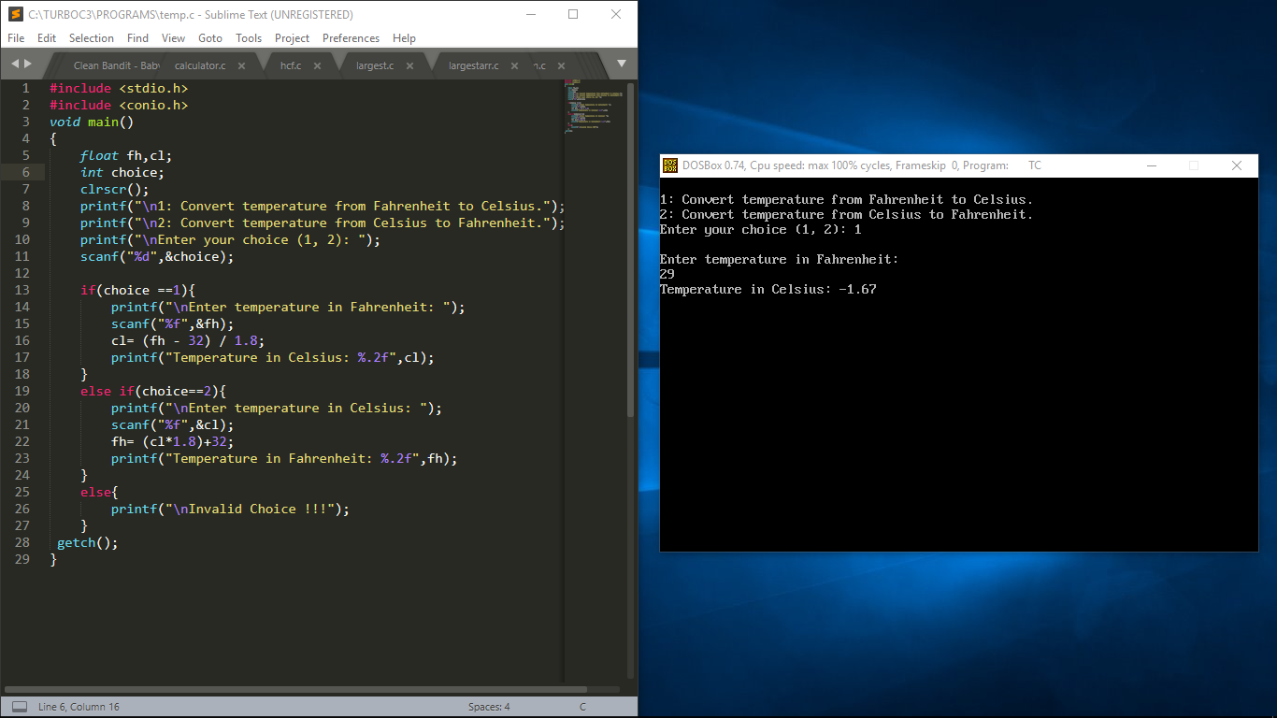

Program to find LCM of two Integers.

#include <stdio.h>

#include <conio.h>

void main()

{

int n1, n2, minMultiple;

clrscr();

printf("Enter two positive integers: ");

scanf("%d %d", &n1, &n2);

minMultiple = (n1>n2) ? n1 : n2;

while(1)

{

if( minMultiple%n1==0 && minMultiple%n2==0 )

{

printf("The LCM of %d and %d is %d.", n1, n2,minMultiple);

break;

}

++minMultiple;

}

getch();

}

Output:

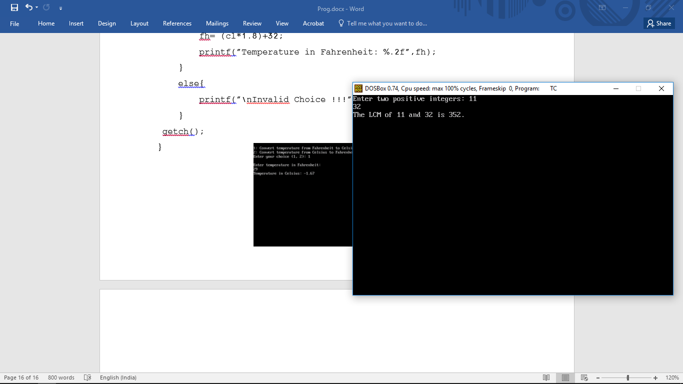

Program to find HCF of two Integers.

#include <stdio.h>

#include <conio.h>

int hcf(int, int);

int main()

{

int a, b, result;

clrscr();

printf("Enter the two numbers to find their HCF: ");

scanf("%d%d", &a, &b);

result = hcf(a, b);

printf("The HCF of %d and %d is %d.\n", a, b, result);

getch();

}

int hcf(int a, int b)

{

while (a != b)

{

if (a > b)

{

a = a - b;

}

else

{

b = b - a;

}

}

return a;

}

Output:

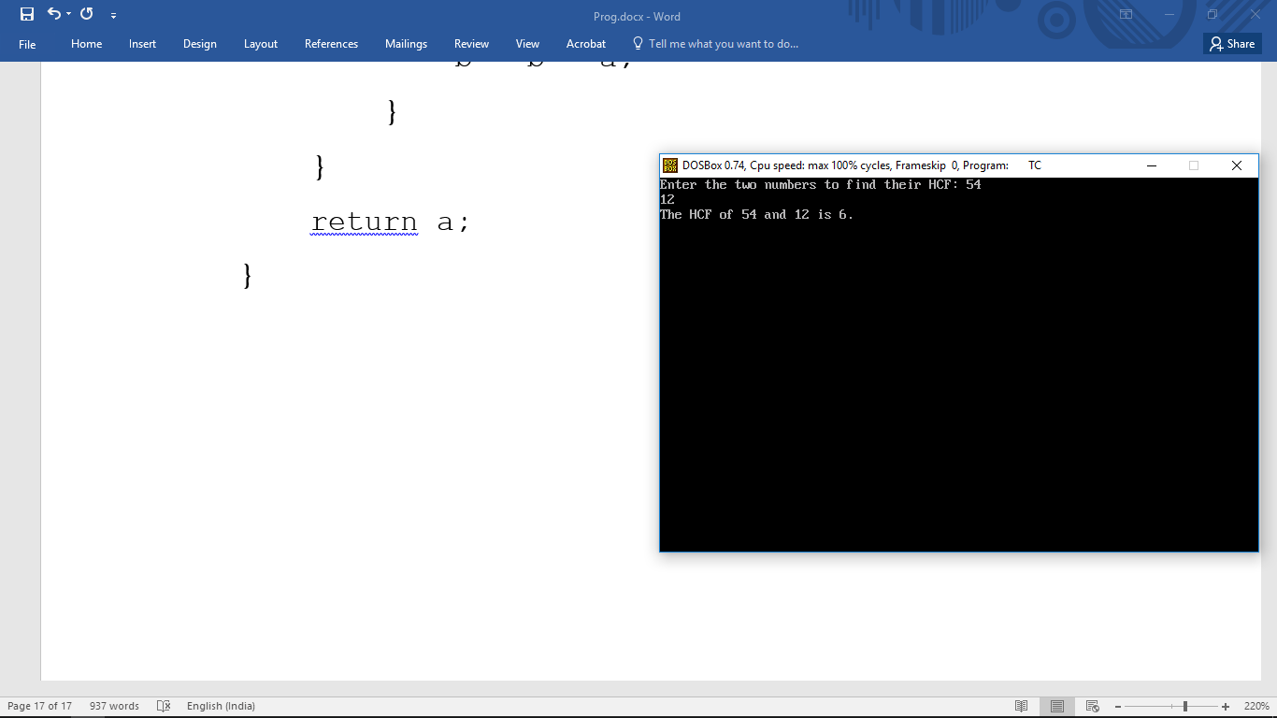

Program to find the Smallest No. out of three numbers.

#include <stdio.h>

#include <conio.h>

void main()

{

int n1, n2, n3;

clrscr();

printf("\nEnter Three Numbers: ");

scanf("%d %d %d" ,&n1 ,&n2 ,&n3);

if ( n1 <= n2 && n1 <= n3 )

{

printf("\n%d is the smallest Number.",n1);

}

else if ( n2 <= n1 && n2 <=n3 )

{

printf("\n%d is the smallest Number.",n2);

}

else

{

printf("\n%d is the smallest Number.",n3);

}

getch();

}

Output:

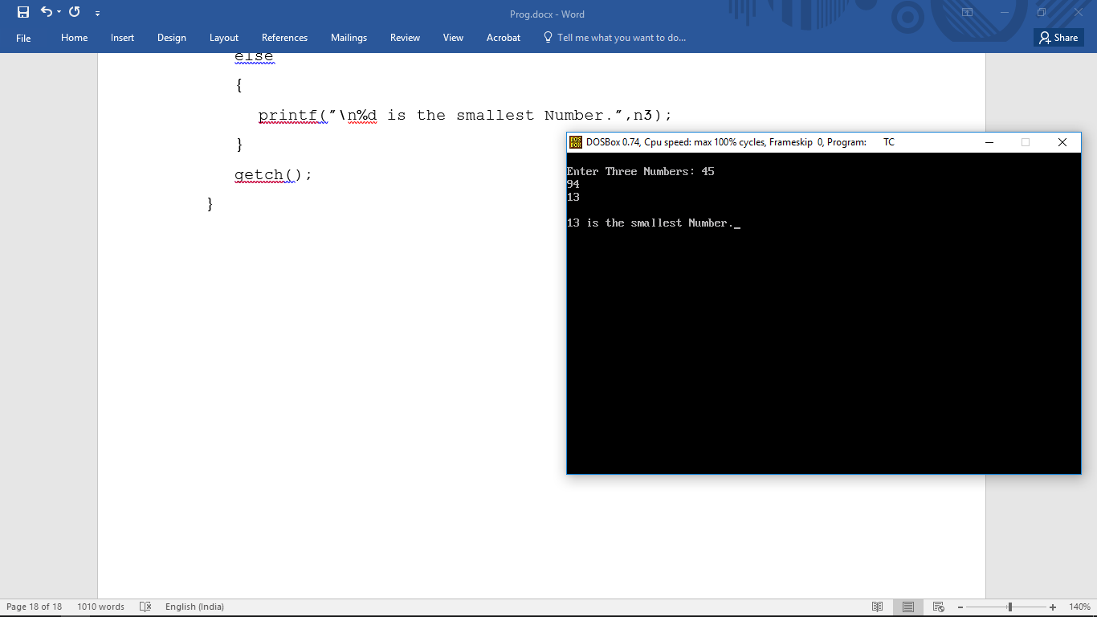

Program to find the exponential value of a Number.

#include <stdio.h>

#include <conio.h>

void main()

{

int base, exponent;

long long result = 1;

clrscr();

printf("Enter a base number: ");

scanf("%d", &base);

printf("Enter an exponent: ");

scanf("%d", &exponent);

while (exponent != 0)

{

result *= base;

--exponent;

}

printf("Answer = %lld", result);

getch();

}

Output:

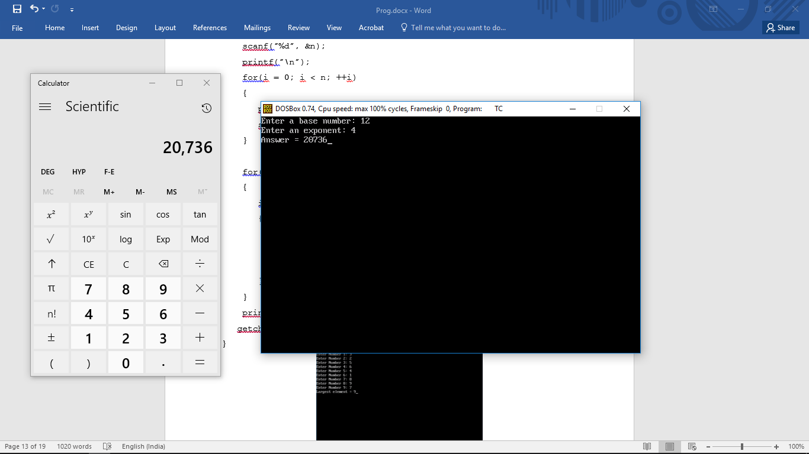

Program to find the Quotient & Remainder of Division.

#include <stdio.h>

#include <conio.h>

void main()

{

int divn, divs, quo, rem;

clrscr();

printf("Enter Dividend: ");

scanf("%d" ,&divn);

printf("\nEnter Divisor: ");

scanf("%d" ,&divs);

{

quo=divn/divs;

rem=divn%divs;

}

printf("\nQuotient: %d" ,quo);

printf("\nRemainder: %d" ,rem);

getch();

}

Output:

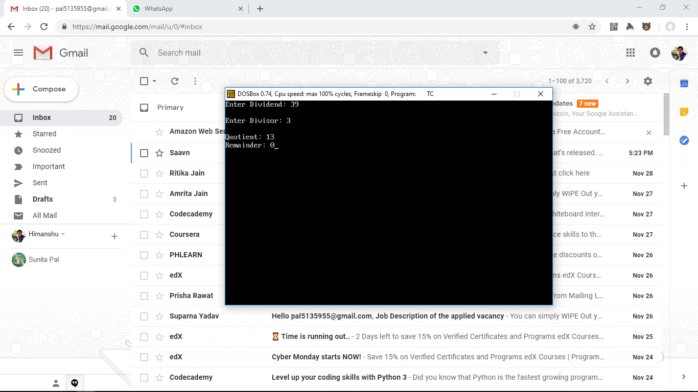

Program to check whether a given no. is prime number or not.

#include <stdio.h>

#include <conio.h>

void main()

{

int n, i, flag = 0;

clrscr();

printf("Enter a positive integer: ");

scanf("%d", &n);

for(i = 2; i <= n/2; ++i)

{

if(n%i == 0)

{

flag = 1;

break;

}

}

if (n == 1)

{

printf("1 is neither a prime nor a composite number.");

}

else

{

if (flag == 0)

printf("%d is a prime number.", n);

else

printf("%d is not a prime number.", n);

}

getch();

}

Output:

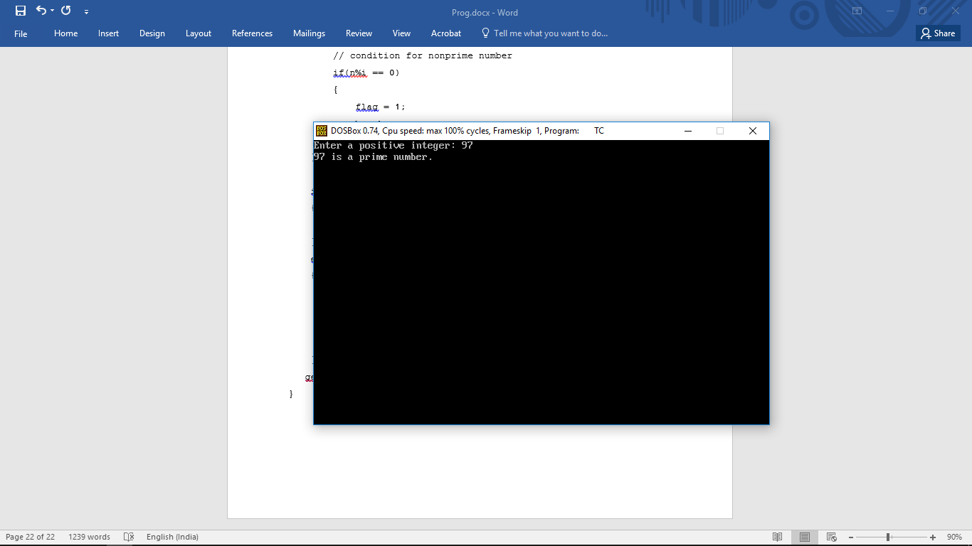

Program to find all prime no’s in a given range.

#include <stdio.h>

#include <conio.h>

void main()

{

int low, high, i, flag;

clrscr();

printf("Enter two numbers(intervals): ");

scanf("%d %d", &low, &high);

printf("Prime numbers between %d and %d are: ", low, high);

while (low < high)

{

flag = 0;

for(i = 2; i <= low/2; ++i)

{

if(low % i == 0)

{

flag = 1;

break;

}

}

if (flag == 0)

printf("%d ", low);

++low;

}

getch();

}

Output:

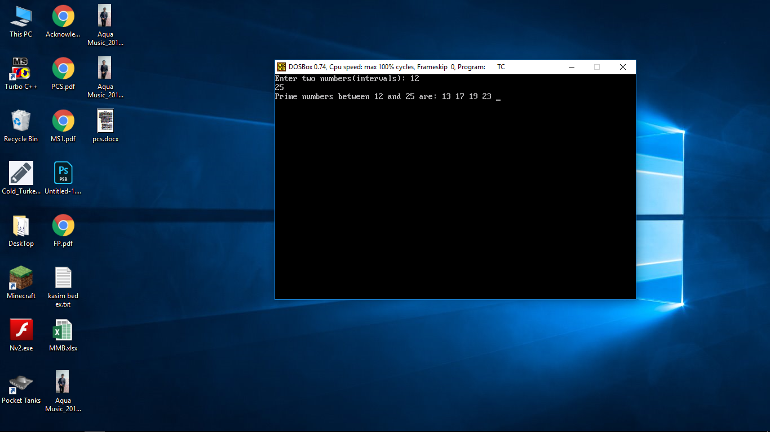

Program to show working of a simple calculator.

#include <stdio.h>

#include <conio.h>

void main()

{

char operator;

double FN,SN;

clrscr();

printf("Enter an operator (+, -, *,): ");

scanf("%c", &operator);

printf("Enter two operands: ");

scanf("%lf %lf",&FN, &SN);

switch(operator)

{

case '+':

printf("%.1lf + %.1lf = %.1lf",FN, SN, FN + SN);

break;

case '-':

printf("%.1lf - %.1lf = %.1lf",FN, SN, FN - SN);

break;

case '*':

printf("%.1lf * %.1lf = %.1lf",FN, SN, FN * SN);

break;

case '/':

printf("%.1lf / %.1lf = %.1lf",FN, SN, FN / SN);

break;

default:

printf("Error! operator is not correct");

}

getch();

}

Output:

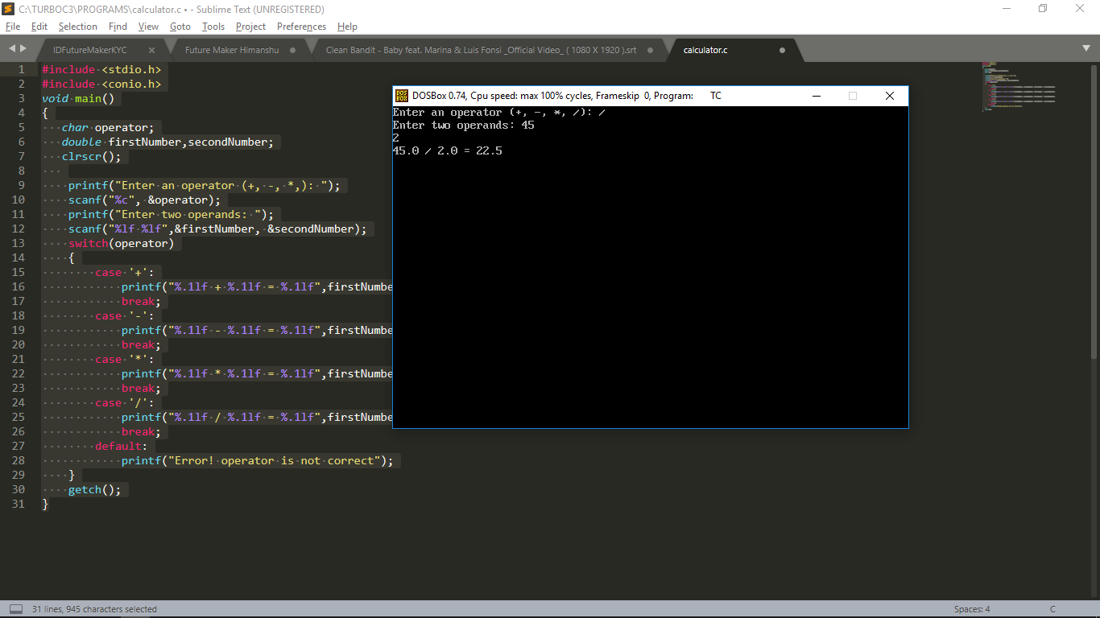

Program to convert Decimal to Binary.

#include <stdio.h>

#include <conio.h>

int main()

{

int n, c, k;

clrscr();

printf("Enter an integer in decimal number system\n");

scanf("%d", &n);

printf("%d in binary number system is:\n", n);

for (c = 31; c >= 0; c--)

{

k = n >> c;

if (k & 1)

printf("1");

else

printf("0");

}

printf("\n");

getch();

}

Output:

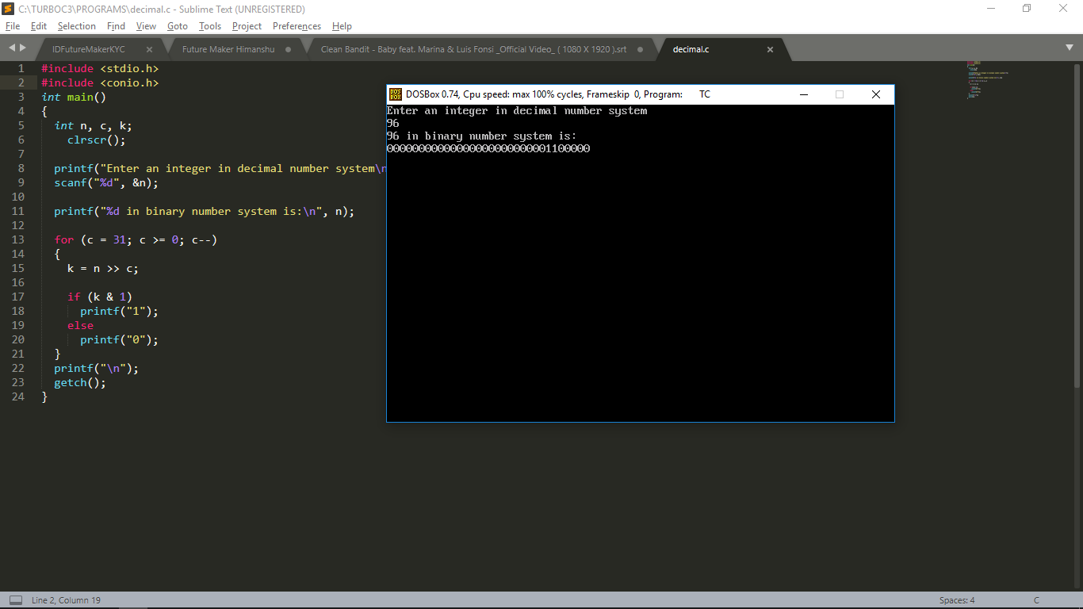

Program to convert Decimal to Hexadecimal.

#include <stdio.h>

#include <conio.h>

int main()

{

long decimalnum, quotient, remainder;

int i, j = 0;

char hexadecimalnum[100];

clrscr();

printf("Enter decimal number: ");

scanf("%ld", &decimalnum);

quotient = decimalnum;

while (quotient != 0)

{

remainder = quotient % 16;

if (remainder < 10)

hexadecimalnum[j++] = 48 + remainder;

else

hexadecimalnum[j++] = 55 + remainder;

quotient = quotient / 16;

}

for (i = j; i >= 0; i--)

printf("%c", hexadecimalnum[i]);

getch();

}

Output:

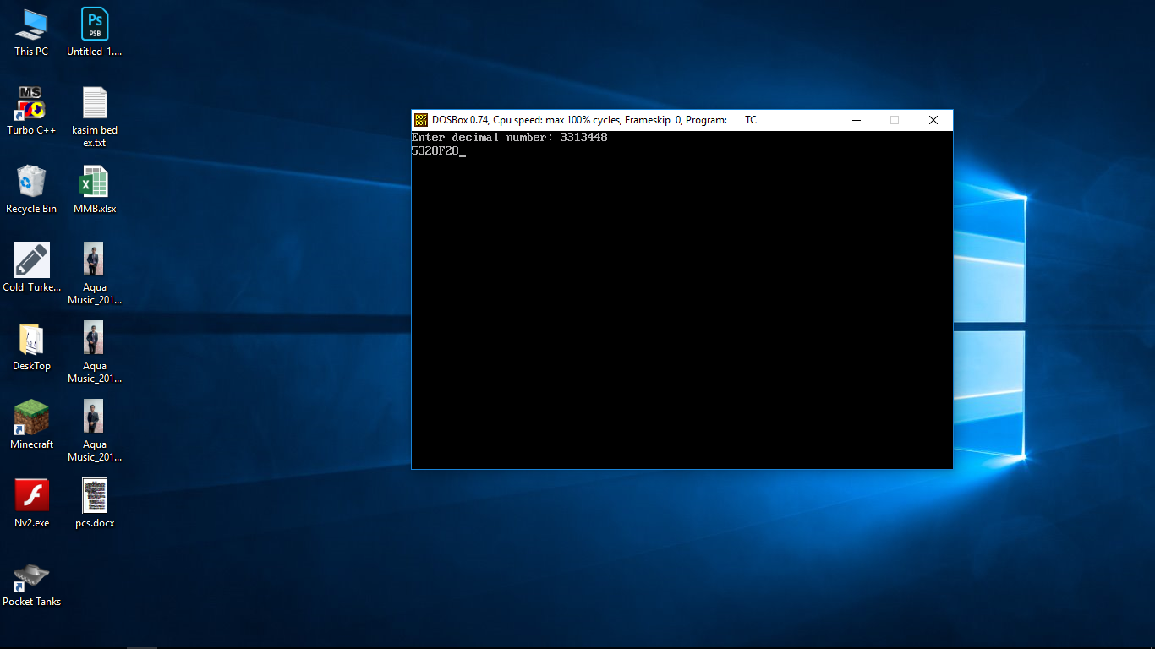

Program to check whether a String is palindrome or not.

#include <stdio.h>

#include <conio.h>

#include <string.h>

void main()

{

Clrscr();

char string[25], reverse_string[25] = {'\0'};

int i, length = 0, flag = 0;

printf("Enter a string \n");

gets(string);

for (i = 0; string[i] != '\0'; i++)

{

length++;

}

for (i = length - 1; i >= 0; i--)

{

reverse_string[length - i - 1] = string[i];

}

for (i = 0; i < length; i++)

{

if (reverse_string[i] == string[i])

flag = 1;

else

flag = 0;

}

if (flag == 1)

printf("%s is a palindrome \n", string);

else

printf("%s is not a palindrome \n", string);

getch();

}

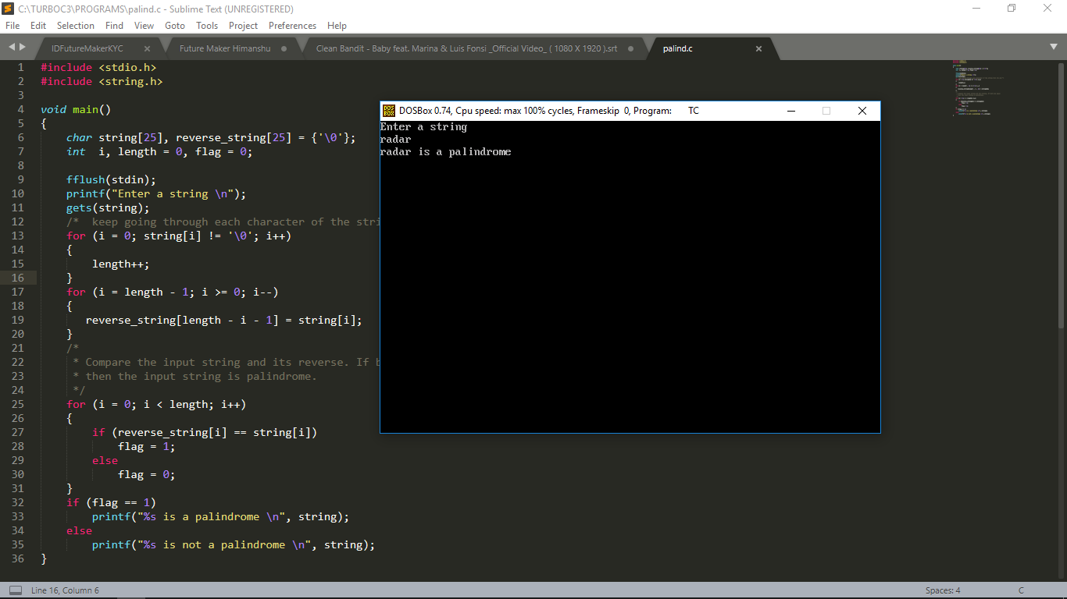Output:

Program to find Determinant of a 3x3 Matrix.

#include<stdio.h>

#include<conio.h>

int main(){

int a[3][3], i, j;

long determinant;

clrscr();

printf("Enter the 9 elements of matrix: ");

for(i = 0 ;i < 3;i++)

for(j = 0;j < 3;j++)

scanf("%d", &a[i][j]);

printf("\nThe matrix is\n");

for(i = 0;i < 3; i++){

printf("\n");

for(j = 0;j < 3; j++)

printf("%d\t", a[i][j]);

}

determinant = a[0][0] * ((a[1][1]*a[2][2]) - (a[2][1]*a[1][2])) -a[0][1] * (a[1][0] * a[2][2] - a[2][0] * a[1][2]) + a[0][2] * (a[1][0] * a[2][1] - a[2][0] * a[1][1]);

printf("\nDeterminant of 3X3 matrix: %ld", determinant);

getch();

}

Output:

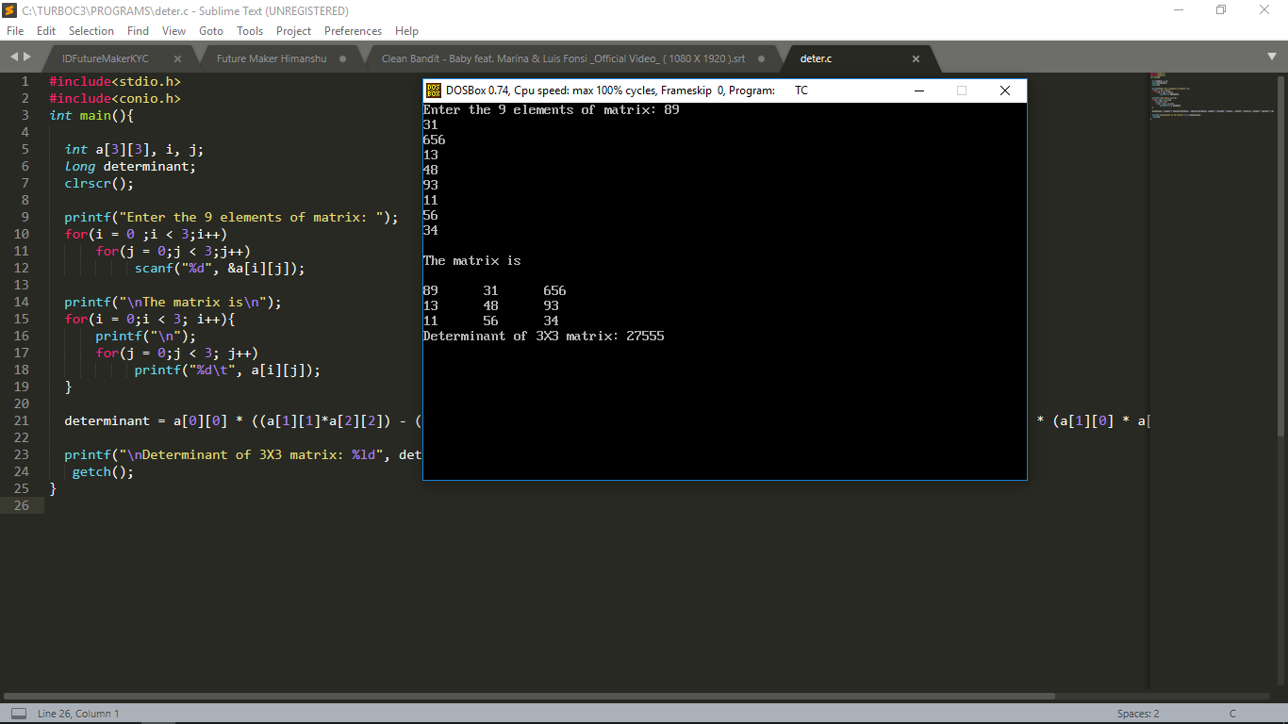

Program to convert Uppercase to Lowercase & Vice Versa.

#include <stdio.h>

#include <conio.h>

#include <ctype.h>

void main()

{

char sentence[100];

int count, ch, i;

clrscr();

printf("Enter a sentence \n");

for (i = 0;(sentence[i] = getchar()) != '\n'; i++)

{

;

}

sentence[i] = '\0';

count = i;

printf("The given sentence is : %s", sentence);

printf("\n Case changed sentence is: ");

for (i = 0; i < count; i++)

{

ch = islower(sentence[i])? toupper(sentence[i]) : tolower(sentence[i]);

putchar(ch);

}

getch();

}

Output:

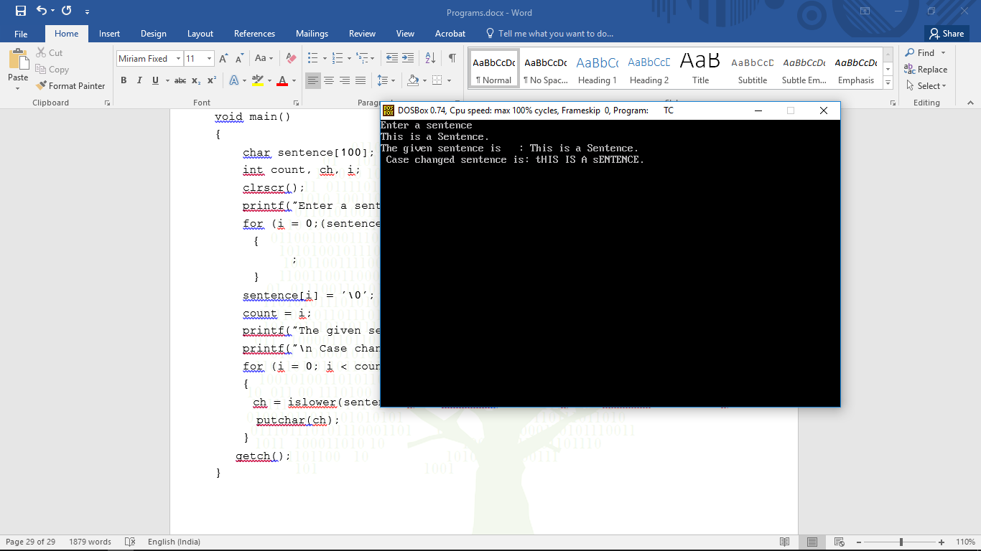

Program to find Largest No. in an Array.

#include <stdio.h>

#include <conio.h>

int main()

{

int array[50], size, i, largest;

clrscr();

printf("\n Enter the size of the array: ");

scanf("%d", &size);

printf("\n Enter %d elements of the array: ", size);

for (i = 0; i < size; i++)

scanf("%d", &array[i]);

largest = array[0];

for (i = 1; i < size; i++)

{

if (largest < array[i])

largest = array[i];

}

printf("\n largest element present in the given array is : %d", largest);

getch();

}

Output:

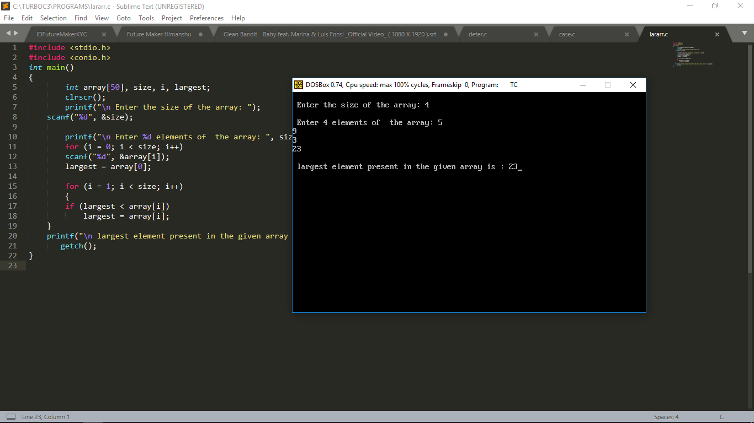

Program to sort a list of integers in ascending order using Bubble Sort.

#include <stdio.h>

#include <conio.h>

int main()

{

int array[100], n, c, d, swap;

clrscr();

printf("Enter number of elements\n");

scanf("%d", &n);

printf("Enter %d integers\n", n);

for (c = 0; c < n; c++)

scanf("%d", &array[c]);

for (c = 0 ; c < n - 1; c++)

{

for (d = 0 ; d < n - c - 1; d++)

{

if (array[d] > array[d+1]) /* For decreasing order use < */

{

swap = array[d];

array[d] = array[d+1];

array[d+1] = swap;

}

}

}

printf("Sorted list in ascending order:\n");

for (c = 0; c < n; c++)

printf("%d\n", array[c]);

getch();

}

Output:

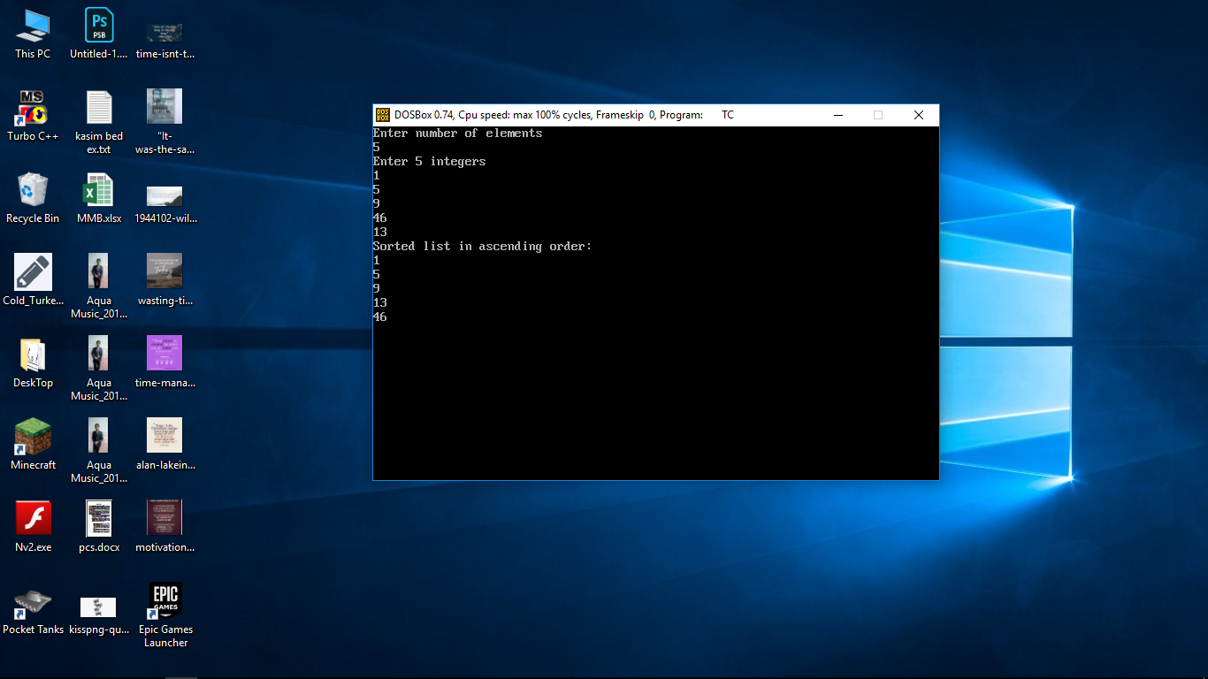

Program to sort a list of integers in ascending order using Insertion Sort.

#include <stdio.h>

#include <conio.h>

int main()

{

int n, array[1000], c, d, t;

clrscr();

printf("Enter number of elements\n");

scanf("%d", &n);

printf("Enter %d integers\n", n);

for (c = 0; c < n; c++)

scanf("%d", &array[c]);

for (c = 1 ; c <= n - 1; c++)

{

d = c;

while ( d > 0 && array[d-1] > array[d]) {

t = array[d];

array[d] = array[d-1];

array[d-1] = t;

d--;

}

}

printf("Sorted list in ascending order:\n");

for (c = 0; c <= n - 1; c++) {

printf("%d\n", array[c]);

}

getch();

}

Output:

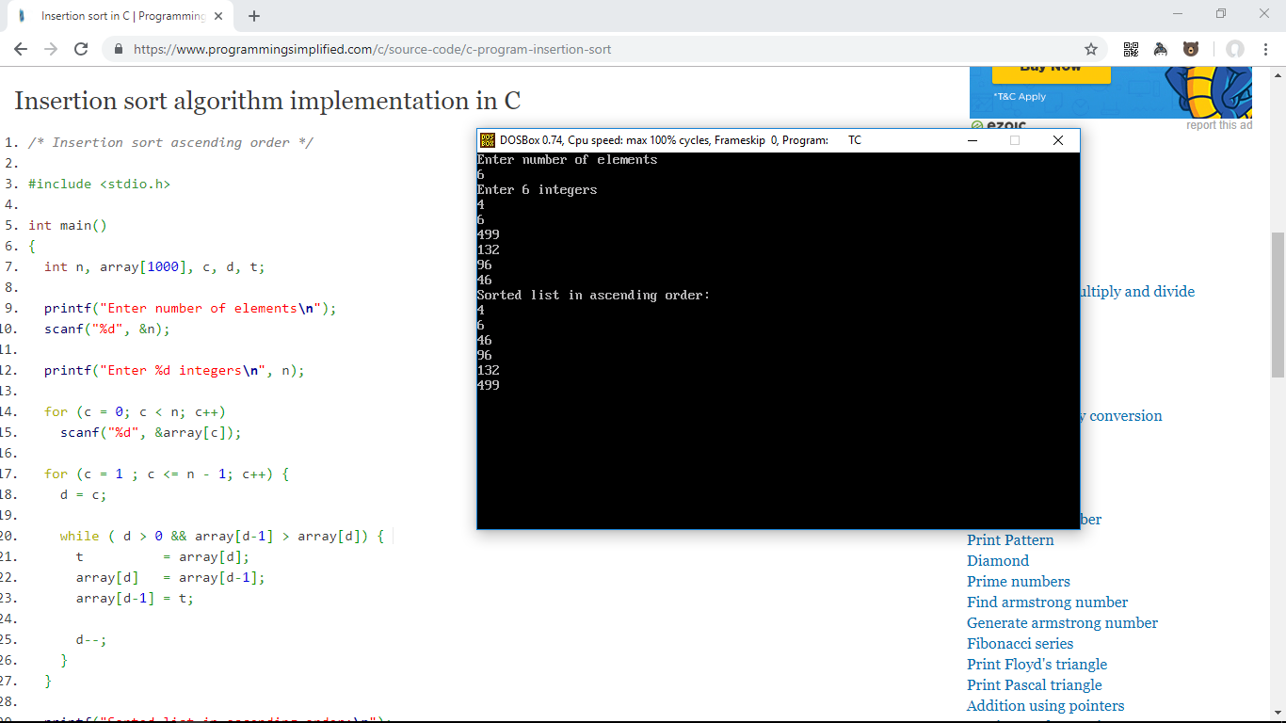

Program to sort a list of integers in ascending order using Selection Sort.

#include <stdio.h>

#include <conio.h>

int main()

{

int array[100], n, c, d, position, swap;

clrscr();

printf("Enter number of elements\n");

scanf("%d", &n);

printf("Enter %d integers\n", n);

for (c = 0; c < n; c++)

scanf("%d", &array[c]);

for (c = 0; c < (n - 1); c++)

{

position = c;

for (d = c + 1; d < n; d++)

{

if (array[position] > array[d])

position = d;

}

if (position != c)

{

swap = array[c];

array[c] = array[position];

array[position] = swap;

}

}

printf("Sorted list in ascending order:\n");

for (c = 0; c < n; c++)

printf("%d\n", array[c]);

getch();

}

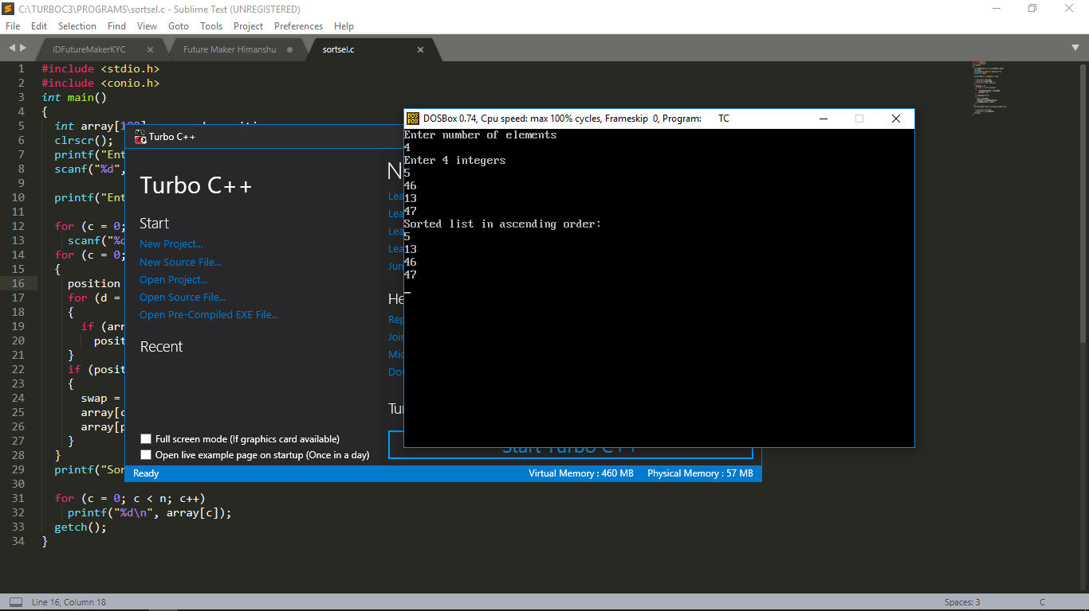Output:

Program to Generate 10 Random No’s in the range of 1 to 100.

#include <stdio.h>

#include <stdlib.h>

#include <conio.h>

int main() {

int c, n;

clrscr();

printf("Ten random numbers in [1,100]\n");

for (c = 1; c <= 10; c++) {

n = rand() % 100 + 1;

printf("%d\n", n);

}

getch();

}

Output:

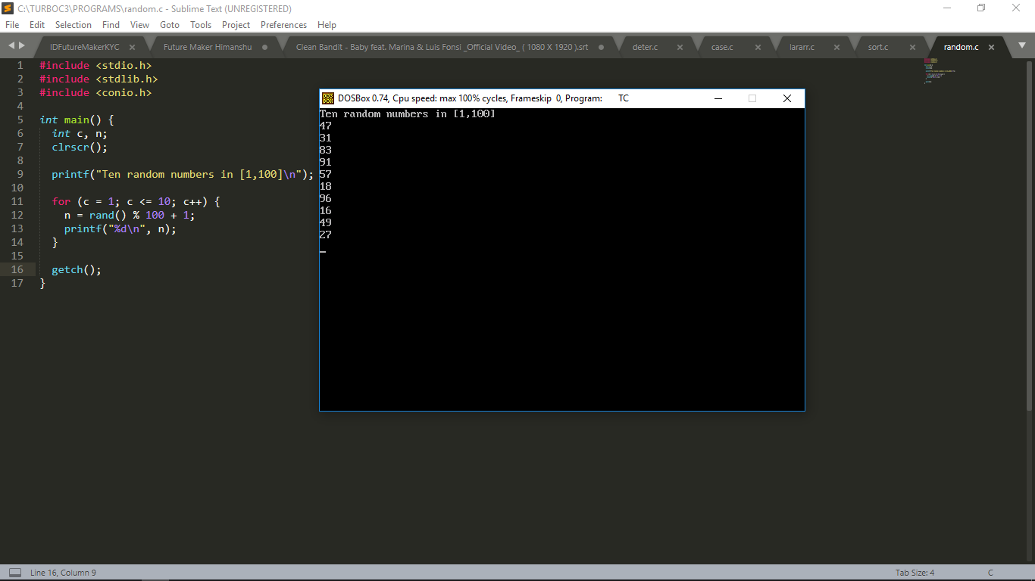

Program to check frequency of repeated character in the string.

#include <stdio.h>

#include <string.h>

#include <conio.h>

void find_frequency(char [], int []);

int main()

{

char string[100];

int c, count[26] = {0};

clrscr();

printf("Input a string\n");

gets(string);

find_frequency(string, count);

printf("Character Count\n");

for (c = 0 ; c < 26 ; c++)

printf("%c \t %d\t", c + 'a', count[c]);

getch();

}

void find_frequency(char s[], int count[]) {

int c = 0;

while (s[c] != '\0') {

if (s[c] >= 'a' && s[c] <= 'z' )

count[s[c]-'a']++;

c++;

}

}

Output:

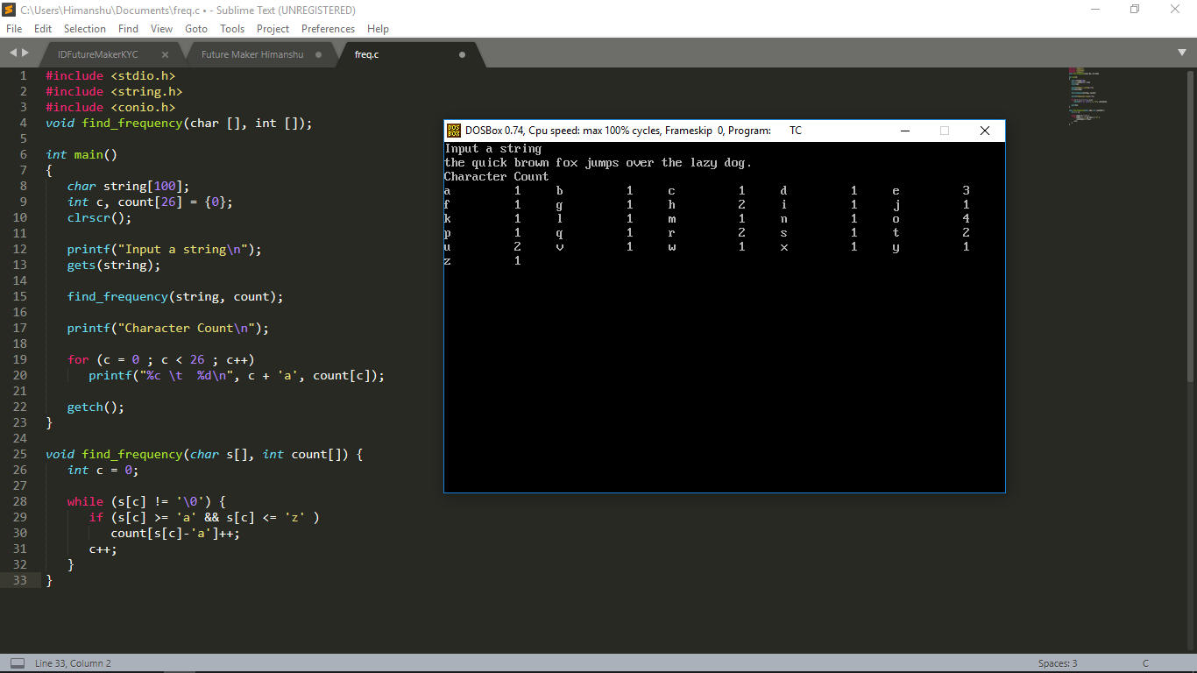

Program to Compare whether two Strings are equal or not.

#include <stdio.h>

#include <string.h>

#include <conio.h>

int main()

{

char a[100], b[100];

clrscr();

printf("Enter a string\n");

gets(a);

printf("Enter a string\n");

gets(b);

if (strcmp(a,b) == 0)

printf("The strings are equal.\n");

else

printf("The strings are not equal.\n");

getch();

}

Output:

